Mobile Based Ethio-Encarta Application



A Senior Project Documentation Submitted in Partial Fulfillment of the Requirement for the Degree of Bachelor of Science in Information System

By Group 6

**Name ID**

1. **AmlakuBeyene ……………………………2051/07**
2. **AsnakeYilak ……………………………….2139/07**
3. **Ylikal Ayalaw ……………… …………….1973/07**
4. **Balemlay Tilahun……………………........1982/07**
5. **Tizta Endresaw …………………………..1984/07**

Supervised by Instructor Fikrte.T

Department: Information System

College of Computing, Department of Information System

Debre Berhan University, Debre Berhan, Ethiopia

Jun 2018 G.C

# Approval

The Project is our own and has not been presented for a degree in any other university with this functionality and all the sources of material used for the project/thesis have been fully acknowledged. (Name and Signature of the project group members)

Name signature

1. AMLAKU BEYENE …………………………………..

2. ASNAKE YLAK ……………………………………

3. YILKAL AYALAW …………………………………..

4. BALEMLAY TILAHUN …………………………………

5. TIZITA ENDRESAW …………………………………

This is to certify that I have read this project and that in my opinion it is fully adequate, in scope and quality, as a project for the degree of Bachelor of Science.

…………………………… ……………………………………….

Name of Advisor Signature

Examiner Name Signature

1. Examiner 1 ………………………………….. ………………………

2. Examiner 2 …………………………………… ……………………….

3. Examiner 3 …………………………………… ……………………….

4. Examiner 4 …………………………………… ……………………….

# Acknowledgement

First of all we would like to thank our GOD for helping us to reach this time and do this project. After we would our honorable advisor instructor Fikrte.T for her great contribution in stimulating suggestion encouragement and advice in all the time we were working on the project.

# Table of contents

Contents Page No

Approval i

Acknowledgement ii

Table of contents iii

List of figures vii

List of tables ix

Abbreviations x

CHAPTER ONE: INTRODACTION OF WHOLE PROJECT PROCESS 1

1.1 Introduction 1

1.2 Background of the project 1

1.3 Statement of the problem 2

1.4 Project Team Organization 2

1.5 Objective of the study 3

1.5.1 General objective 3

1.5.2 Specific objective 3

1.6 Scope and limitation of The Project 3

1.6.1 Scope of the project 3

1.6.2 Limitation of the project 4

1.7 Significant of the system 4

1.8 Beneficiary of the system 4

1.9 Feasibility study 6

1.9.1 Economic Feasibility 6

1.9.2 Technical Feasibility 7

1.9.3 Operational Feasibility 7

1.9.4 Political and legal feasibility 7

1.10 Methodology 8

1.10.1 Data collection method 8

1.10.2 System analysis and design methodology 8

1.10.3 CASE Tools 9

1.10.4 System development environment 10

1.10.5 Tasting procedures 10

1.11 Risks and contingencies 11

CHAPTER TWO: DESCRIPTION OF THE EXISTING SYSTEM 12

2.1. Introduction to the existing system 12

2.2. Players in the existing system 12

2.3. Major functions or activities in the existing system 12

2.3.1. Navigate 12

2.3.2. View 12

2.4. Business rules 13

2.5. Forms and other documents of the existing system 14

2.5.1. Documents of the existing system 14

2.6. Bottlenecks of the existing system 17

2.7. Practices to be preserved 18

2.8. Proposed solution for the new system 18

2.9. Requirements of the proposed system 19

2.9.1. Functional requirements 19

2.9.2. Non-functional requirements 19

CHAPTER THREE: SYSTEM ANALYSIS 21

3.1. System models 21

3.1.1. Scenarios 21

3.1.2. Use case model 22

3.1.3. Use case Description 24

3.1.4. Object Model 29

3.1.4.1. Data Dictionary 29

3.1.4.2. Analysis Level Class Diagram 30

3.2. Dynamic model 32

3.2.1. Sequence Diagram 32

3.2.2. Activity Diagram 36

3.2.3. State Diagram 41

3.3. User Interface Prototype (navigational paths and screen mock-ups) 45

CHAPTER FOUR: SYSTEM DESIGN 48

4.1. Introduction 48

4.1.1. Purpose of System Design 48

4.1.2. Design Goals 48

4.2. Current Software Architecture 50

4.3. Proposed Software Architecture 50

4.3.1. Overview 50

4.3.2. Subsystem Decomposition 51

4.3.3. Hardware/Software Mapping 54

4.3.4. Persistent Data Management 54

4.3.4.1. Mapping 55

4.3.4.2. Database Design 56

4.3.5. Access Control and Security 57

4.3.6. Boundary conditions 57

4.4. Subsystem services 58

4.5. Component Diagram 58

4.6. Deployment Diagram 60

CHAPTER FIVE: OBJECT DESIGN 61

5.1. Introduction 61

5.2. Object Design Trade-off 61

5.3. Interface Documentation Guideline 62

5.4. Packages 62

5.5. Class Interfaces 63

CHAPTER SIX: IMPLEMENTATION AND TESTING 64

6.1. Introduction 64

6.2. Final Testing of the System 64

6.3. Hardware Software Acquisition 65

6.4. User Manual Preparation 66

6.5. Training 66

6.6. Installation Process 66

6.7. Start-up strategy 86

CHAPTER SEVEN: CONCLUSION AND RECOMMENDATION 87

7.1. Conclusions 87

7.2. Recommendation 88

References 91

Bibliography 91

# List of figures

Figure 1: Existing system document 14

Figure 2: Existing system Clickable Image Documents 15

Figure 3: Existing system Menu documents 16

Figure 4: Use Case Diagram 23

Figure 5: Class diagram 31

Figure 6: Sequence diagram for login 33

Figure 7: Sequence diagram for search 34

Figure 8: Sequence diagram for Update Information 35

Figure 9: Login activity diagram 37

Figure 10: view information activity diagram 38

Figure 11: Add Information activity diagram 39

Figure 12: Search information activity diagram 40

Figure 13: State Diagram for Login 41

Figure 14: State Diagram for search 42

Figure 15: State Diagram for Manage Account 43

Figure 16: State Diagram for Upload Information 44

Figure 17: User Interface prototype for Amharic mobile 45

Figure 18: User Interface prototype for English mobile 46

Figure 19: User Interface Prototype for Administer page 47

Figure 20: Current Software Architecture 50

Figure 21: Proposed System Architecture 51

Figure 22: Proposed System Subsystem Decomposition 53

Figure 23: Proposed System Hardware and Software Mapping 54

Figure 24: Database Mapping 55

Figure 25: Database design 56

Figure 26: Component Diagram 59

Figure 27: Deployment Diagram 60

Figure 28: Amharic mobile user menu items 67

Figure 29: Amharic mobile user menu items 68

Figure 30 :Setting for Application 69

Figure 31: Login page 70

Figure 32: Search Information 71

Figure 33: Meanu 72

# List of tables

Table 1: Team Organizations 2

Table 2: Use case Description for Login 25

Table 3: Use case Description for upload information 26

Table 4: Use case Description for View Information 26

Table 5: Use case Description for Search Information 27

Table 6: Use case Description for Upload Information 28

Table 7: Data dictionary for Administer 29

Table 8: Data dictionary for Information Recorder 29

Table 9: Data dictionary for Users 29

Table 10: Data dictionary for Account 30

Table 11: Data dictionary for Information 30

Table 12: Access control and security 57

Table 13 Testing 65

# Abbreviations

**MBEEA** Mobile Based Ethio-Encarta Application.

**JDK** Java Development Kit.

**IDE** Integrated Development Environment.

**CD** Compact Disc.

**DVD** Digital Versatile Disc.

**RAM**Random Access Memory.

**DBU** Debre Berhan University

**GPS** Global Position System

**OOSAD** Object Oriented System Analysis and Design

**IDE** Integrated Development Environment

**UML** Unified Modeling Language

**I/O**Input or Output

**OS** Operating System

**UC** Use Case

**.APK**is a file extension type on the android application file.

**FK**Foreign Key

**PK**Primary Key

**DBMS**Database Management System

**HTTP**Hypertext Transfer Protocol.

**HTTPS**Hypertext Transfer Protocol Security

**XAMP** cross platform apache MySQL PHp

**PHP**Hypertext Preprocessor

**SQL**Standard Query Language

**CBD** Component Based Development

**JDBC** Java Data Base Connectivity

**TCP**Transmission Control Protocol

**IP**Internet Protocol

# CHAPTER ONE: INTRODACTION OF WHOLE PROJECT PROCESS

## Introduction

Ethiopia is a country located in the Horn of Africa. Ethiopia, the oldest independent nation in Africa, has a heritage dating back to first century AD. Some of the oldest skeletal evidence for anatomically modern humans has been found in Ethiopia. It is widely considered as the region from which modern humans first set out for the Middle East and places beyond.

Ethiopia has its own culture, nation nationality, tradition, calendar, custom, metabolism and type’s cultural game. However; in the context of our country there is absence of technology which supports both literate and illiterate users on the case of information broadcasting in the form of encyclopedia or multimedia system. Correspondingly mobile phones are necessary part of people’s life. There are continuously risingnumbers of mobile computing applications, centered on the people’s daily life. Mobile phones have high impact on delivering information to users. Therefore the objective of the proposed system is developing information delivery system which combines both encyclopedia (Encarta) concept and mobile technology

## Background of the project

In Ethiopia peoples obtained information through newspaper, books, and through information elicitation. Even if the users use the above mentioned ways to get information it is difficult to them to get accurate and timely information. Not this problem only hindered the citizens also lack of accurate information (content) has impact on tourists or anyone who needs information about Ethiopia. As they try to access information they may face different problems like shortage of information about a place or famous peoples and so on. In order to solve such the above problems these project proposed to develop an application that simplifies the work of humans by simply set upping the application to their mobile application. It will satisfy customers by providing accurate, available, and usable system which will be accessed 24/7.

## Statement of the problem

* There was content mismatch in the existing system. The user can’t get accurate information.
* The existing system didn’t support local language.
* The existing system wasn’t available to the user 24/7.
* The system wasn’t enable the users to search and find information easily

## Project Team Organization

The project team composed of five members.

|  |  |  |
| --- | --- | --- |
| Team Members | Id | Tasks |
| AmlakuBeyene | 2051/07 | Requirement engineer ,designer and Implementer |
| AsnakeYlak | 2139/07 | Requirement engineer, Designer and Tester |
| YlikalAyalaw | 1973/07 | Requirement engineer,Designer,Tester |
| BalemlayTilahun | 1982/07 | Requirement engineer ,Analyst and Tester |
| TiztaEndresaw | 1984/07 | Requirement engineer, Implementer and Testing |

Table 1: Team Organizations

## Objective of the study

### General objective

The general objective of this project is to design and implement mobile based Ethio-Encarta system.

### Specific objective

To achieve the general objective, the following specific objectives is listed

* To acquire the necessary information and knowledge from different sources by using appropriate methodology.
* To elicit information to understand the problem of the existing system in order to propose a better and a working solution.
* To analysis the system functional and nonfunctional requirement.
* To design the proposed system based on the analysis
* To implement and test the proposed system
* To forward recommendations and suggestions for further work in mobile application.

## Scope and limitation of The Project

### Scope of the project

The scope of this project is to develop mobile based Ethio-Encarta system in local language and foreigner language.

* Our system contains
* Historical place
* Famous people
* Cultural Games in Ethiopia
* religions
* History of Ethiopian music, dance style and others
* Environment
* agriculture

### Limitation of the project

The scope of the project work is limited to the following:

* The proposed system only support android based mobile.

## Significant of the system

Since the application provides an information who wants to access.

* It reduces cost or save money.
* Users will access the needed information easily for different use.
* Researcher to collect information easily for research and other purposes.
* For students those have an interest to study about their country.
* It saves too much of time consumption by easily access information by his/her mobile phone or smart phone.
* Users know what Ethiopia has in different direction like today and past.
* Used for truism office for the tourist see this application and access information about Ethiopia and need to see this truism.

## Beneficiary of the system

The proposed project provides the design and implementation of mobile based Ethio-Encarta system. After the implementation these project will benefit

* For the community
* The application can easily help Ethiopian people to get information about their country. Such as: culture, history and etc.
* The user can gate the information in timely.
* The people outside the country can get information about Ethiopia and know about what it has.
* To decrease the cost to buy books means the information access on his/her smart information.
* The community is full of knowledge about Ethiopia and motivates to practice the research based on the information he/she get.
* Minister of Tourism office
* The tourist or foreigners use the information in Ethio-Encarta and easily understand about Ethiopia and what it has.
* The application developed on both Amharic and English language then the truism office is transfer information about Ethiopian truism.
* The tourist can easily know about Ethiopia and visited Ethiopia and the tourism can get money from tourist.
* For developers
* To capture different information about Ethiopia.
* To increase our knowledge about Ethiopia.
* Developing the proposed application will enhance the team member’s to understand the technology behind developing mobiles.

## Feasibility study

Feasibility study is essential to evaluate the cost and benefits of the new system. On the basis of the feasibility study decision is taken on whether to proceed or to cancel the project.

### Economic Feasibility

Economic feasibility is a measure of how cost effective the proposed solution will be. It is possible to develop the proposed system in minimum cost and also can be hosted in lower price.

Economic feasibility is also used to identifying the financial benefits and costs associated with the application being developed. The Ethio-Encarta application develops is economically feasible for user since it enables the user easily accessible the application with minimum cost and use efficiently. And it will have tangible and intangible benefits.

**Tangible benefits:** are benefits consequent from the design of a system.

* Can be considered as money.
* money for performing different operation

**Intangible benefits**: are benefits consequent from the design of an application that cannot be easily considered as money.

The following are intangible benefits for the new application:

* It reduces time wastage
* Increase moral satisfaction of users

**Tangible costs**: are costs consequent from the design of the application that can be considered as money, so that the costs for machine described below in cost estimation. And we can divide the cost consumptions into hardware and software costs.

**Intangible costs**: are costs consequent from the design of an application that cannot be easily considered as cost like time requires for adjusting new application and Analysis of the existing system.

### Technical Feasibility

General the study of the project is technically feasible, since there will not be much difficulty in getting required resources for the development and maintaining the application as well. All the resources needed for the development of the application as well as the team also have a great knowledge about the system to be developed.

### Operational Feasibility

Operational feasibility is a measure of how well a proposed system solves the problems, and takes advantage of the opportunities identified during scope definition and how it satisfies the requirements identified in the requirements analysis phase of the development. The proposed project accepted to be operational feasible in such a way that it will provide end users with timely, accurate and useful formatted information. It will be providing cost effective information.

### Political and legal feasibility

This project purposely develops for eliminating the gap exists in the previous system and to initiate the user’s interest to use the application. So there is no impact in political as well as legal issues. Our system is not conflict with government of the past and the current because our system is about history truism culture, nation nationality, tradition, calendar, custom, and metabolism.

## Methodology

### Data collection method

The requirement of the system is gathered using primary and secondary data collecting techniques. These are listed below.

**Observation:** The project team observes people and tourist need information about Ethiopia then the user in many directions and the tourist can shortage of information and the current mobile based Ethio Encarta application is not addressee about Ethiopia and for Ethiopian users the application is developed in English language so difficult to use.

**Encyclopedia:**

An encyclopedia is a book, or series of books, that contains general information about many topics and subjects. While often found with dictionaries in resource libraries, encyclopedias may be much longer and contain more information about the subjects within them. In the past, these works were collected in multiple published volumes. More modern publications, however, include digital formats such as software on a disc or websites with information on them. Then first data collection method by analyzing and viewing the encyclopedia about Ethiopia.

**Document analysis:**

This is a secondary data collection method used for analyzing the document prepared in the existing system. We analyzed different documents like letters and magazines samples in the past. And also we use internet, this is the way of exploring information or data using the web. In this way we can gather more information than any other data.

### System analysis and design methodology

Among the different methodologies available our project teams have used object oriented system analysis and design methodology for the development of the proposed system. Because it promises to reduce development time, reduce the time and resources required to maintain existing application and increase code reuse. In addition, it supports some important concepts and terminology which has made it popular among programming methodology. It also supports important features of object oriented programming like inheritance, polymorphism, data hiding, encapsulation, overloading and reusability. We use also procedural method on server side because it simple and more understandable method by team members.

### CASE Tools

Software and hardware tools are necessary for the development and simulation of the project. The following tools are used to develop the proposed system:

* Software
* Android Studio Eclipse: we will use this software to design the proposed system. It is a Multilanguage integrated development environment (IDE) comprised a base workspace and an extensible plug-in system for customizing the environment.
* JDK for the whole java environment.
* Android SDK used for the android application platform
* Client side coding HTML.
* Client side scripting JavaScript.
* XAMPP (Apache, MySQL, PHP) to develop website for information providers.
* Enterprise architect: for diagrams like use case, sequence diagrams, class diagrams, UML diagrams, deployment diagrams, system architecture, communication protocol, and time schedule.
* Sql Server Management Studio: we use this software for database design.
* Languages
* JAVA (programming language) XML (markup language) HTML (markup language) CSS (markup language)
* Hardware Tools
* Desktop or laptop computer with 4 GB RAM, 400 GB hard disk and 2.0 GHz CPU speed or higher. (this specifications are a minimum requirement)
* 16 GB or higher flash disk to transfer files and to keep backups.
* Android phone to test the system.
* Printer to print the documentation.
* Storage devices: hard disk, flash disc.
* Internet cable.
* Display Card: Super video graphics Adapter (SVGA)
* Keyboard Standard:104 Enhanced Keyboard

### System development environment

The software package is expected to work in the following atmosphere:

* Editor Tools
* Microsoft Office Word: -We will use Microsoft office word to type our project work.
* Power Point: We will use it to present our presentation in short and brief way.
* Microsoft stack consisting of,
* Operating system----------Windows 10.
* Processor--------------------Pentium core i5
* Clock speed ----------------1.8 GHz
* RAM-------------------------6 GB
* Hard Disk-------------------1000 GB
* Android studio management.
* Koplayer.
* Java, Java Query.
* MySQL.

### Tasting procedures

Testing is a trial experience in which the deliverables of the project are checked with acceptable Standards in the project. We used unit testing, and system testing to test the correctness of each Module and the compiled program.

* Unit Testing: We use unit testing to test the individual functional component of our system before testing the whole system once.
* System Testing: System testing is comparing Function of the system developed in relation with expected function of the system.
* Integrating Testing: For verifying as the whole system is functioning in integrated manner with respect to the goal of our system.

## Risks and contingencies

During the development of the project there may be different problems that we may face. These are:

* **Unfortunate failure of system:** To handle this problem the teams have some method to resist not completely but partially by using back up mechanisms using flash disks, CD/DVD and by storing the data in more than two computers.
* **Virus attack:** It is difficult to control data from virus but try to scan the data, installing and updating antivirus software.
* **Time management problem:** we solve this problem by working cooperatively, divide our time by schedule for each phase of the project and we try to use this schedule effectively
* **Failure of electric power, computer and internet connectivity:** we try to solve this by taking back up to external storage devices, using CDMA for the internet and using laptop that have high power backup, (using UPS) other power storing mechanisms.
* **One of our group members may be sick while in the process of project development**: to solve this problem the remaining group member together covers this member done.
* Therefore whatever situation happen or occurred that hinder during the progression of the

# CHAPTER TWO: DESCRIPTION OF THE EXISTING SYSTEM

## Introduction to the existing system

The current Ethio-Encarta system is implemented on foreigner’s language English. And the current Ethio-Encarta system is focus on the information in historical place, famous people, transport system, bank, hotel, region and realign. But the application not broadcast the information based on its contents and the information is not good to accesses and makes confusion and the existing mobile based Ethio-Encarta application is not broadcast full information about Ethiopia. The existing system not implemented with Amharic language.

## Players in the existing system

Players represent external entities that interact with the system. Due to this we will deal only with persons involved on those services or persons who have responsible for this work.

Here are the players involved:

* All Peoples (The peoples that read English language):people who are getting information from the system.

## Major functions or activities in the existing system

### Navigate

The current Ethio-Encarta applications allow the users or a person that needs information to access the data or information by navigating the menu means the current Ethio-Encarta application is menu based to use this by navigating the menu and access the information.

### View

Users can access the information about Ethiopia in English language and different contents about Ethiopia then the user see the information.

## Business rules

A business rule is effectively an operating principle or polices that we try to specify for both the existing system. The business rule is a principle or a policy in which the proposed system operates accordingly.

The main business rules or principles of the existing system are: -

* BR1- Before using Encarta application, peoples must install the application to their device.
* BR2- The administer can have user name and password to perform work.
* BR3-The information recorder can be login first

## Forms and other documents of the existing system

### Documents of the existing system

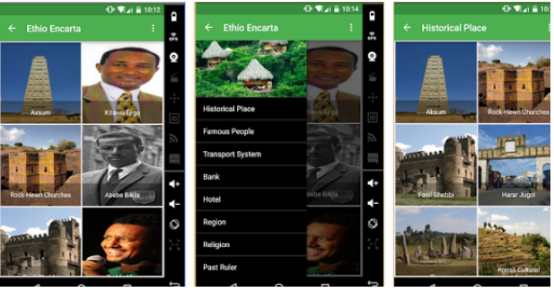

Figure 1: Existing system document

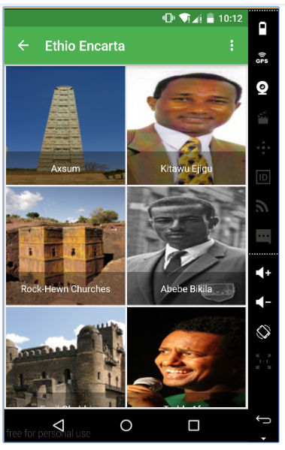

Figure 2: Existing system Clickable Image Documents

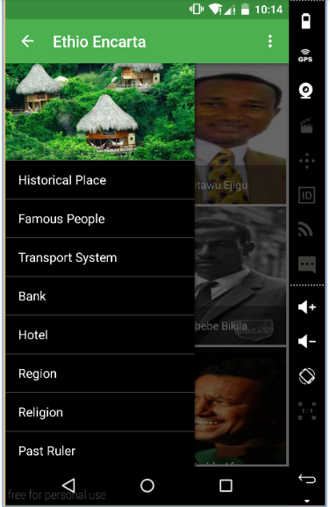

Figure 3: Existing system Menu documents

## Bottlenecks of the existing system

The existing system actually faces to a lot of problems. Such as:

1. Performance
2. Unfortunately failure—the application is have an error massage or the serves is stopped.
3. II. Information (Input, Output and stored data)
4. Outputs

* Lack of fully information.
* Difficult to get information or files based on given categories or menus.
* Inaccurate Information may occur.
* Information is repeated.

1. Inputs: The current Ethio-Encarta Application not supports users to input information or message and feedback.
2. Stored data

* Data is stored redundantly in multiple files times.
* Stored data is not accurate.
* Data is not flexible -- not easy to meet new information current time.

1. Availability: The current or the existing system not broadcast full information about the given categories in the catalog and the information is not clear.
2. Efficiency Problems

* People waste time to perform activities
* Data is redundantly output or copied
* Data is redundantly processed
* Information is redundantly generated

1. VI. Service Problems

* The system produces inaccurate results
* The system produces inconsistent results
* The system produces unreliable results
* The system is inflexible to new or exceptional situations
* The system is inflexible to change

## Practices to be preserved

In this application the developer try tot*alks* about Ethiopia and what it has then this practice is good because the application objective is can advert Ethiopia to foreigners. In current Ethio-Encarta Application the user interface and the information is image based and it is easy to understand the information.

## Proposed solution for the new system

Our group proposed solutions for the new system is starts from the existing system limitations that are:-

* The existing system is not supports searching information then our proposed solution is the system is supports information searching simply..
* The existing system is not broadcast full information about their categories: -means the data or information is not clear then our proposed solution is the system design or implement by our group is should be clear and easy to use.
* The existing system cannot support information updates online then the proposed system can supports online updates of information.
* The existing system cannot support the users can give feedback then the proposed system can support this future.

## Requirements of the proposed system

### Functional requirements

The functional requirements of the system are concerned about the major activities that the system has to be performed. Some of them are:

* **REQ 1. View:**The system enables the user to view information
* **REQ 2. Search:**The system enables the user to search the intended information.
* **REQ 3.**Manage Information: The system enables the administrator to manage information (upload information, update information, delete information, view information)

### Non-functional requirements

Non-functional requirements, as the name suggests, are requirements that are not directly concerned with the specific services delivered by the system to its users. They may relate to involving system properties such as reliability, response time and performance. Alternatively, they may define constraints on the system implementation such as the capabilities of input output devices or the data representations used in interfaces with other systems. Non-functional requirements, such as performance, security, or availability, usually specify characteristics of the system as a whole.

It describes aspects of the system that are concerned with how the system provides the functional requirements. The proposed system has the following nonfunctional requirements.

* **Availability**: This system should always be available for access at 24 hours; 7 days a week and the end users can easily access the application anywhere anytime.
* **Security**: Administer is authenticated before managing the information or manage information. The system should provide a better level of security or accesses level and integrity of the data held by the system as compared to the current system, only authorized person of the system can gain access to the organization secured page on the system; and only administrator with valid password and username can login to view user’s page.
* **Performance and Response time:** - The system should have high performance rate when executing user’s input and should be able to provide feedback or response fast time.
* **Usability**: The system allow users to access and operate on it, because the user interfaces are easily understandable and user guide line will prepared to help users to access the system
* As the system support Amharic language the illiterate user who can’t read and understand English language can easily understand the proposed system
* Users can understand easily because of the system can provide the menus with image.

# CHAPTER THREE: SYSTEM ANALYSIS

## System models

Model is an abstraction of the real world. It allows us to deal with the complexity current in a real-world problem by focusing on the essential and interesting features of an application.

The techniques and associated notation used for object oriented analysis and design in incorporated in to a standard object oriented language called unify Modeling language (UML).

Generally, the system model designing part points on developing the requirement and analysis models for the proposed Application using the UML use case model, sequence diagram, activity diagram and class diagram using Object-Oriented Software Engineering (OOSE) and interface prototyping are also included.

### Scenarios

A use case is an abstraction that describes all possible scenarios involving the described functionality. A scenario is an instance of a use case describing a concrete set of actions.

**Actor**: - The purpose of actor analysis is to identify all of the actors that interact with the system. An actor has a role in that interacting with the system. The actors of our Ethio Encarta application are described in below.

**Administrator**: A person who is responsible to manage account (deactivate, create, update).

**Information recorder:** the personnel who is responsible to manage information (upload, update and delete) .

**User:** person that use Ethio Encarta application.

**Use case: -**Identifying the activities that are mainly performed on the proposed system is the basic thing in analyzing a new system. The following use cases have been identified from the system specification

* Login
* View information
* Search information
* Manage information
* Upload information
* Delete information
* Manage user account
* Add account
* Deactivate account

### Use case model

A use case defines a goal-oriented set of interactions between external users and the system under consideration or development. Thus a Use Case Scenario is a description that illustrates, step by step, how a user is intending to use a system, essentially capturing the system behavior from the user's point of view.

In order to create relevant use cases for the system, the following actors for the system have been identified:-

* Users
* Administer
* Information recorder

The following are use cases used in the system:

* Login: Administrator login into the system.
* View information: The user view information their smart phone.
* Search: The user can search the information.
* Manage information: The administrator can manage information means upload, delete and update information.
* Upload information: The Administrator can upload information.
* Delete information: The administrator can delete the information that is not necessary.
* Manage user account: The administrator can manage accounts add and delete the account.
* Add account: The administrator can add account.
* Deactivate account: Make it deactivate account.

[B](http://en.wikipedia.org/wiki/Use_Case)elow is the use case diagram for Mobile based Ethio-Encarta application.



Figure 4: Use Case Diagram

### Use case Description

|  |  |  |
| --- | --- | --- |
| Use case Name | Login | |
| Use case id | UC-01 | |
| Actor | Administer and information recorder | |
| Description | Administer Login to system in order to have privileges for performing different tasks. | |
| Precondition | Administer and information recorder must have user account. | |
| Post condition | Administer and Information Recorder can successfully logged in to the system and the administer page can displayed. | |
| Basic course of action | Actor action | System response |
| 1. The Administer and Information Recorder launches the system.  3. Administer and Information Recorder can click the “Login link”.  5. Administer and Information Recorder enter username and password and click login button.  7. The user can see or view information.  8. Use case end. | 2. Systems display the “Home page”.  4. System displays the “Login form”.  6. If username and password is correct, the corresponding page is display (**A6**: if username and password incorrect). |
| Alternative course of action | **A6:** If username and password is incorrect.   * System can display error message on home page login form. * The Administer can enter username and password again. | |

Table 2: Use case Description for Login

|  |  |  |
| --- | --- | --- |
| Use case Name | Upload Information | |
| Use case id | UC -02 | |
| Actor | Information Recorder | |
| Description | Information Recorderuploads the information based on given categories. | |
| Precondition | Information Recorder must login to a system. | |
| Post condition | Information Recorder upload information and save information. | |
| Basic course of action | Actor action | System response |
| 1. The Information Recorder enter in to home page and click upload information.  3. Information Recorder can add information and click the “save button”.  5. Use case end. | 2. Systems display the “The upload form”.  4. If the information is found the corresponding page is display (**A3**: The information not found or empty). |
| Alternative course of action | **A3:**If Information Recorder uploads empty information.   * System can display error message on home page login form place enter the information. * The Information Recorder can enter the information. | |

Table 3: Use case Description for upload information

|  |  |  |
| --- | --- | --- |
| Use case Name | View information | |
| Use case id | UC-01 | |
| Actor | User | |
| Description | This use case is used to the user view information about its needed | |
| Precondition | User must have install application to phone  User must be entering to the application. | |
| Post condition | Users view information | |
| Basic course of action | Actor action | System response |
| 1. The user launches the system.  2. The users select the need information catalog.  4. The user can be click the needed categories  6. The user can see or view information.  7. Use case end. | 3. Systems display the information in catalog.  5. System displays the information based on the selected category. |
| Alternative course of action | -user can search information without navigation. | |

Table 4: Use case Description for View Information

|  |  |  |
| --- | --- | --- |
| Use case Name | Search Information | |
| Use case id | UC-02 | |
| Actor | User | |
| Description | This use case is used to the user search information about its needed | |
| Precondition | User must have install application to phone  User must be entering to the application. | |
| Post condition | Users search Information | |
| Basic course of action | Actor action | System response |
| 1. The user launches the system.  3. The users select the search text box and enter the text then press the search button.  5. The user can be view information  6. Use case end. | 2. Systems display the search view.  4. System displays the information based on the entered text(Alternative courseA3:If The information is not found) |
| Alternative course of action | **A3:** The user can try again if the search result not found.   * The use case end. | |

Table 5: Use case Description for Search Information

|  |  |  |
| --- | --- | --- |
| Use case Name | Upload Information | |
| Use case id | UC -06 | |
| Actor | Information Recorder | |
| Description | The Information Recorder Upload Information | |
| Precondition | Information Recorder must be entering to the server application.  Information Recorder must log to the system.  Information Recorder must enter to its own page. | |
| Post condition | Information Recorder must be Upload the new Information at accurate categories. | |
| Basic course of action | Actor action | System response |
| 1. The Information Recorder must have the Information.  2. The Information Recorder must be selecting the new Information categories.  4. The Information Recorder write or upload information and click save.  6. Use case end. | 3. Systems display the selected categories of information.  5.System save information |

Table 6: Use case Description for Upload Information

### Object Model

### Data Dictionary

This gives a brief description of the field names used in the tables and what they define as per the databases.

|  |  |  |  |
| --- | --- | --- | --- |
| FliedName | Data Type | Size | Description |
| Administer_Id | Varchar | 20 | Hold the name of Administer. |
| First_Name | Varchar | 20 | Hold the first name of Administer. |
| Last _Name | Varchar | 20 | Hold the last name of Administer |
| Password | Varchar | 20 | Indicates password to be secure. |

Table 7: Data dictionary for Administer

|  |  |  |  |
| --- | --- | --- | --- |
| FliedName | Data Type | Size | Description |
| First Name | Varchar | 20 | Hold the first name. |
| Last_Name | Varchar | 20 | Hold the last name. |
| Email | Varchar | 20 | Hold the Email. |
| Id | Varchar | 30 | Hold the id. |
| Password | Varchar | 30 | Hold the Password. |

Table 8: Data dictionary for Information Recorder

|  |  |  |  |
| --- | --- | --- | --- |
| FliedName | Data Type | Size | Description |
| User_Id | Varchar | 20 | Hold the Id of User. |

Table 9: Data dictionary for Users

|  |  |  |  |
| --- | --- | --- | --- |
| FliedName | Data Type | Size | Description |
| Account_Id | Varchar | 20 | Hold the Id of Account. |
| User_Name | Varchar | 20 | Hold the first name of Administer. |
| Password | Varchar | 20 | Indicates password to be secure. |

Table 10: Data dictionary for Account

|  |  |  |  |
| --- | --- | --- | --- |
| FliedName | Data Type | Size | Description |
| Information_Id | Varchar | 20 | Hold the Id of Information. |
| Categories | Varchar | 20 | Hold the Categories of Information. |
| Administer_Id | Varchar | 20 | Hold the name of Administer. |

Table 11: Data dictionary for Information

### Analysis Level Class Diagram

Class diagram shows the static structure of an object-oriented model the object class, their internal structure, and the relationships in which they participate. Class diagram represents a detailed view of a single use case, shows the classes that participate in the use case, and documents the relationship among the classes.

The class diagrams are widely used in the modeling of object oriented systems because they are the only UML diagrams which can be mapped directly with object oriented languages. The class diagram shows a collection of classes, interfaces, associations, collaborations and constraints. It is also known as a structural diagram.



Figure 5: Class diagram

## Dynamic model

### Sequence Diagram

Sequence diagram describe behavior as a sequence of messages exchanged among a set of objects. Sequence diagram which is also known as interaction diagrams are one of the diagrams seed in UML, for modeling the dynamic aspects of the system. It shows an interaction consisting of a set of objects and their relationship including message that may be dispatched among them. It emphasizes the time ordering of messages. A sequence diagram is an interaction diagram that emphasizes ordering of message.



Figure 6: Sequence diagram for login



Figure 7: Sequence diagram for search



Figure 8: Sequence diagram for Update Information

### Activity Diagram

An activity diagram illustrates the dynamic nature of a system by modeling the flow of control from activity to activity. An activity represents an operation on some class in the system that results in a change in the state of the system. Typically, activity diagrams are used to model workflow or business processes and internal operation. Because an activity diagram is a special kind of state chart diagram, it uses some of the same modeling conventions. Activity diagrams are mainly used as a flow chart consists of activities performed by the system. But activity diagram are not exactly a flow chart as they have some additional capabilities. These additional capabilities include branching, parallel flow etc.



Figure 9: Login activity diagram



Figure 10: view information activity diagram



Figure 11: Add Information activity diagram



Figure 12: Search information activity diagram

### State Diagram

State chart diagram is used to model dynamic nature of a system .They defines different states of an object during its lifetime. And these states are changed by events. They describe the flow of control from one state to another state.



Figure 13: State Diagram for Login



Home screen

Figure 14: State Diagram for search



Information recorder page

Figure 15: State Diagram for Manage Account



Information recorder page

Figure 16: State Diagram for Upload Information

## User Interface Prototype (navigational paths and screen mock-ups)

A mobile user can have several operations to do. Below is listed some of the major interfaces that a mobile user can face while accessing the mobile based Ethio-Encart application.

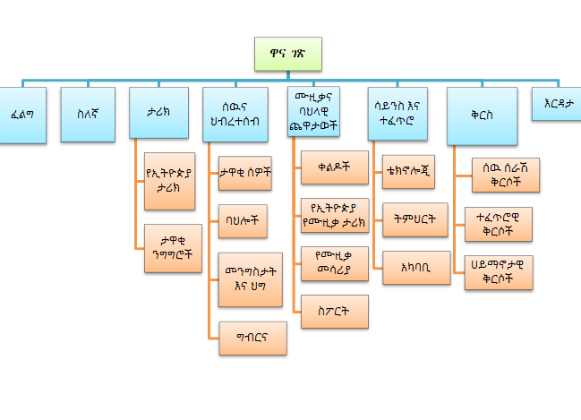

Figure 17: User Interface prototype for Amharic mobile

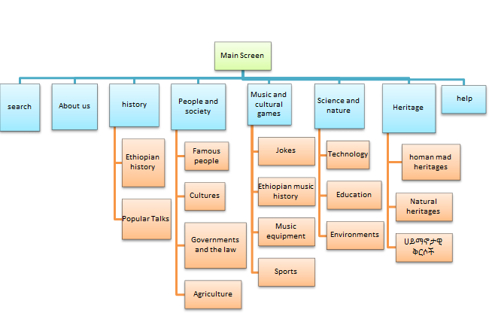

Figure 18: User Interface prototype for English mobile

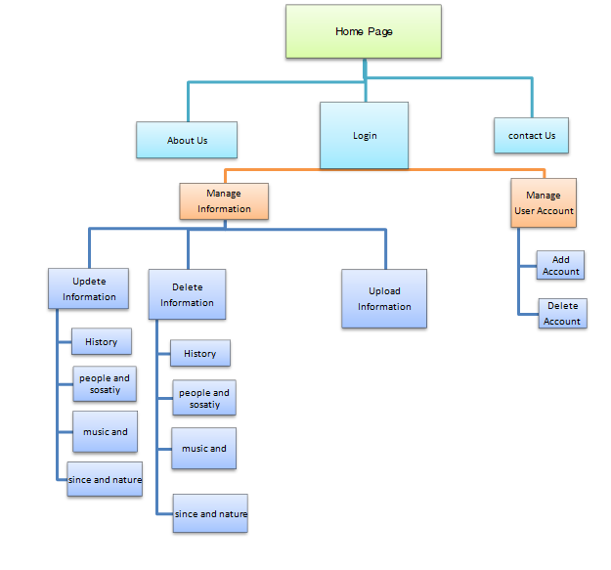

Figure 19: User Interface Prototype for Administer page

# CHAPTER FOUR: SYSTEM DESIGN

## Introduction

System design is the transformation of the analysis model into a system design model. In this chapter the project team discusses about the higher level description of Mobile Based Ethio-Encarta Application. In this chapter we included the following concepts such as the purpose of the system, design goals, current and proposed software architectures, subsystem decomposition, hardware/software mapping, persistent data management, access control and security, component and deployment diagrams.

### Purpose of System Design

System designing in terms of software engineering has its own value and importance in the system development process as a whole. The purpose of the System Design is to supplement the system architecture providing information and data useful and necessary for implementation of the system elements. To provide sufficient detailed data and information about the system and its system elements to enable the implementation consistent with architectural entities as defined in models and views of the system architecture. Design definition is the process of developing, expressing, documenting, and communicating the realization of the architecture of the system through a complete set of design characteristics described in a form suitable for implementation. Define what methods or mechanisms we use to achieve requirements of the system, fill the gap between the system specification produced during requirements elicitation and analysis and make the system easily manageable by individual team member.

### Design Goals

Design goals are derived from the nonfunctional requirement of the system which is the description of the feature characteristics and attribute of the system as well as any constraints that may limit the boundary of the proposed solution. Design goals describe the qualities of the system that the developers should consider. The following are the design goals of the proposed system.

* **Security:** The system should provide a better level of security and integrity of the data, only authorized person (administer) of the system can gain access to the secured page on the system; and only administer with valid password and username can login to view administer page. Database security, to prohibit the database from an unauthorized access, shall be implemented using PHp Authorization and Authentication feature.
* **Performance and Response time:** The system should have high performance rate when executing user’s input and should be able to provide feedback or response within a short time span.To meet system performance:-
* Using pup up and tabs to minimize page reload which is take much time when reload the page many times for the specific functionality.
* Avoiding redundancy of codes increase the time of operation and memory space of the system.
* **Usability:** The system allow users to access and operate on it, because the user interfaces are easily understandable and user guide line will prepared to help users to access the system. To meet usability we will design the system like:
* To remove any ambiguity regarding the consequences of an action e.g. clicking on Add/delete.
* Help –the system have help disk how to use the system.
* **Availability:** This system should always be available for access at 24 hours, 7 days a user’s can simply access the application.

## Current Software Architecture

The current Software Architecture is given below.

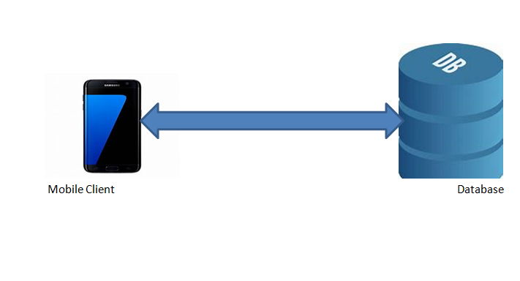

Figure 20: Current Software Architecture

## Proposed Software Architecture

### Overview

The software architecture of Ethio-Encarta application shows which data will be persistent and what type of storage will be used to save them. The access control will also be described in this section, and then we will show the global software flow and control.

* **Presentation Layers or User Interface:** Layer Presentation layer is a user interface layer where we can design our Mobile Based Ethio-Encarta Application. Where we can make design with controls. UI is an intermediate between user and business logic layer. This is the layer through which users give input to get the desired output**.**
* **Business Logic Layer (BLL):** Business layer is intermediate or middle layer that communicate presentation layer and Data access layer. Business layer used to validate input condition and correct the date before calling method from the data layer. In Business layer we can write PHp, Android and java code and validation code as per the project requirements.
* **Data Access Layer (DAL):**Data Access Layer used to make connection with database server. In data access layer we can write database query, stored procedure for insert, update, delete, select operation on database. This layer only communicates with Business logic layer.

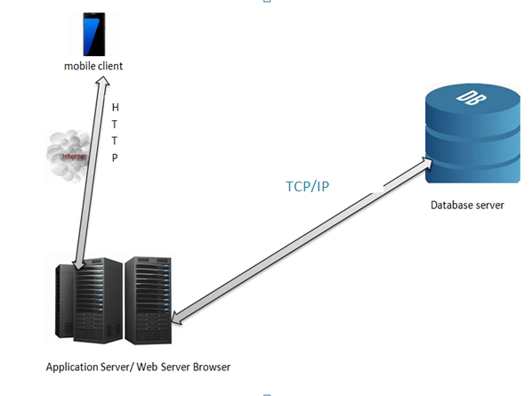

TCP/IP

Figure 21: Proposed System Architecture

### Subsystem Decomposition

The process of “subsystem decomposition” can increase the levels of abstraction in software architecture. The goal of subsystem decomposition is to obtain weak coupling between subsystems.

Our system is decomposed into the following subsystems.

* User Account management subsystem: This subsystem has the following functional requirements.
* Delete user account
* Create user account
* Manage Information Subsystem
* Upload Information
* Delete Information
* Users Subsystem
* Search Information
* View Information
* Information subsystem

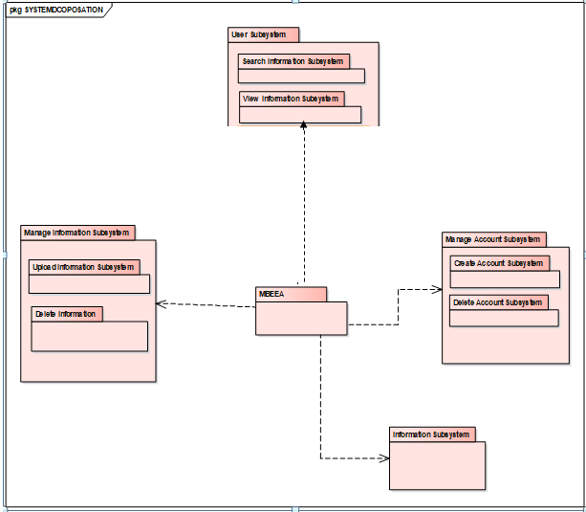

Figure 22: Proposed System Subsystem Decomposition

### Hardware/Software Mapping



Figure 23: Proposed System Hardware and Software Mapping

### Persistent Data Management

We use object-oriented databases for our system instead of relational databases, so instead of designing E-R diagram we use persistence models to show the mappings and the relations of tables. The purpose of persistence modeling is which objects in the system design are required to be stored persistently. Information is persistent data, which should be stored in the Database Management System. This allows the programs that operate on these data to do consistently. Moreover, storing data in a database enables the system to perform complex queries on a large data set.

### Mapping

In order to store information persistently we map objects into tables and the attributes into fields to the specific table based on the objects found on the system. Therefore, we identified four major tables that will be implemented on the system. For this reason, the mapping of objects to tables is displayed as follows:-

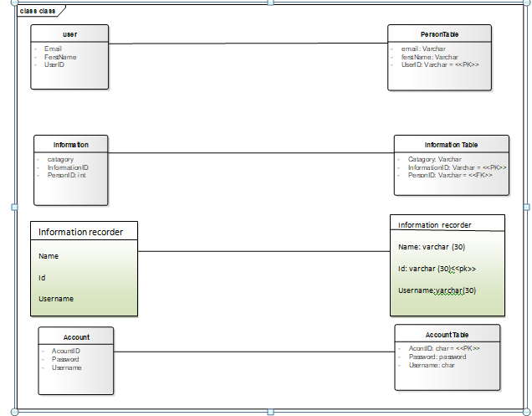

Figure 24: Database Mapping

### Database Design

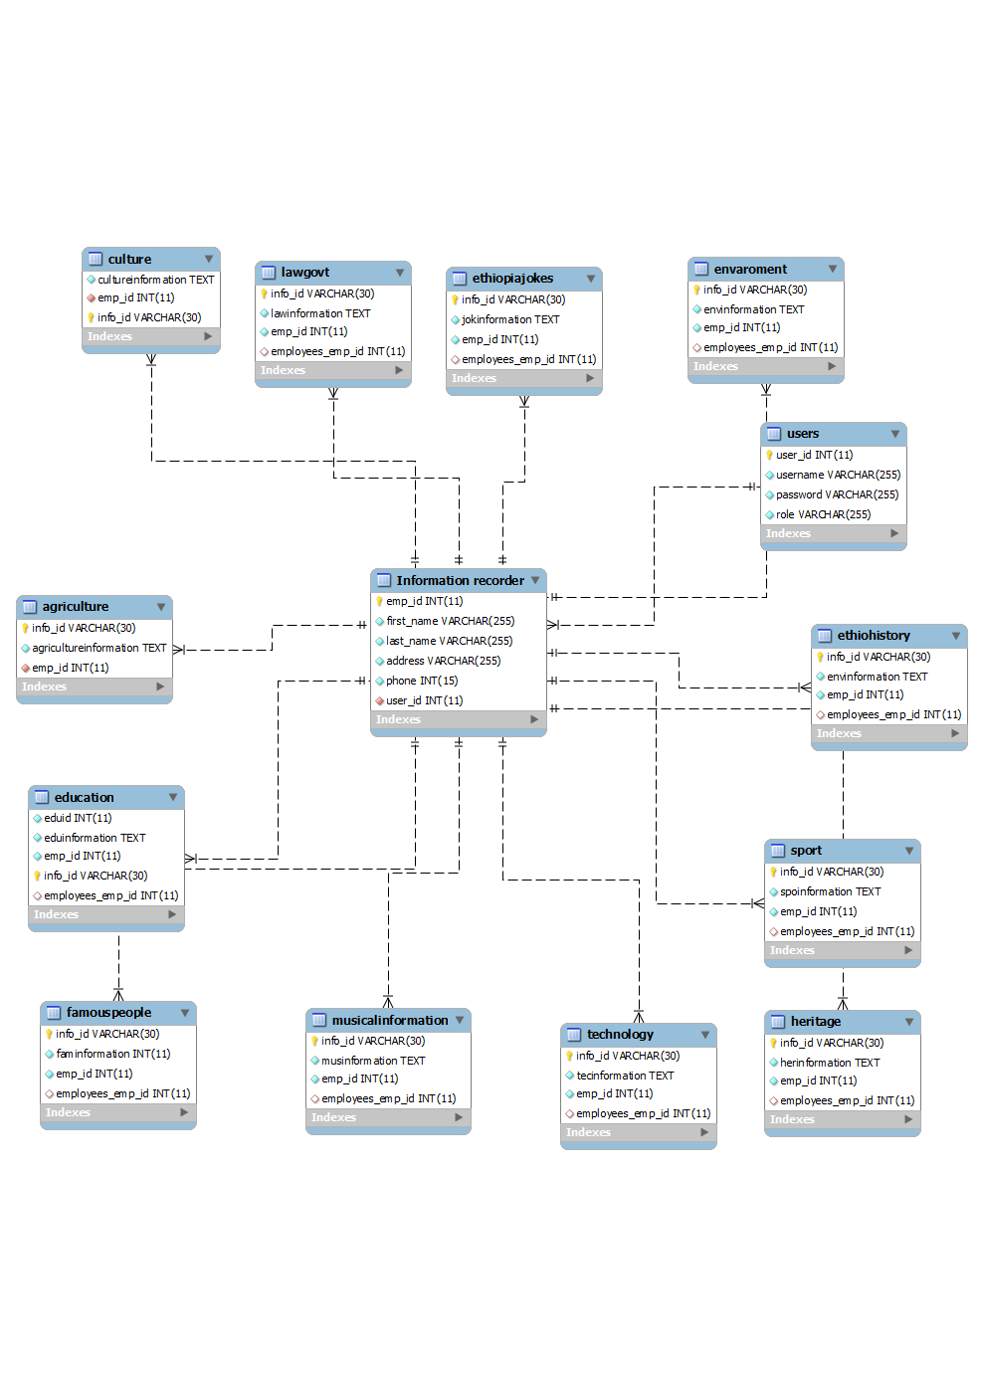

Figure 25: Database design

### Access Control and Security

Here clearly describe the way we will use to secure our system and the issues associated with access control within our system; we should also specify which actions are given to which user under what condition. Access to the system must be controlled by creating different authentication levels and using password for login purposes. Multiple levels of security protect sensitive documents and files from unauthorized users. Each user has a security access level and each document has a sensitivity level.

|  |  |  |
| --- | --- | --- |
| Functions | Actors | |
| Users | Administer |
| Login | 🗶 | ✓ |
| Upload Information | 🗶 | ✓ |
| Update Information | 🗶 | ✓ |
| Manage account | 🗶 | ✓ |
| View Information | ✓ | ✓ |
| Search Information | ✓ | ✓ |

Table 12: Access control and security

### Boundary conditions

The boundary condition includes the processes from the deployment of the system to exit condition.

* Welcome/main page or main screen of the System: At the time the Administer or user starts to use this system first this main page or main screen will be displayed respectively and after this page or screen the Administer or user can access different pages or information respectively based on his/her need online or offline.
* Administer Login page: The login page contains the user name and password and users should enter the correct username password and their privilege correctly to get the page that he/she wants.
* The Administer enter user name
* The Administer enter password
* Click ‘Login’
* User Home Screen: The user can start the Mobile Based Ethio-Encarta Application and access different information as they needed and search information, give comment, and listen in voices.
* Error/Failure: Conditions Occur when Administer enters invalid user name and password or add empty information and user input is invalid when search information.
* Shut Down: Administer click log out and close browser our system has a client server architecture that allows remote access and when the user wants to leave from Mobile Based Ethio-Encarta Application close the application by device close button.

## Subsystem services

Subsystem services are services which are performed in each sub systems. Those subsystems Services are described each individually as below.

**User Subsystem**: A person who use android phone to access the Mobile based Ethio-Encarta application and get information about Ethiopia in this subsystem the user can search information, view information, copy information, listen information and Give comment is provided in this subsystem.

**Administrator**: The Administer can manage User account is provided in this subsystem. The Administer performs the following.

* + Manage user.
  + Create account.

## Component Diagram

Component Diagram This diagram depicts the components of the system and their interaction. Actors and their corresponding activities are illustrated by the component diagram.



Figure 26: Component Diagram

## Deployment Diagram

Deployment diagrams model the physical architecture of a system, and it shows the relationships between the software and hardware components in the system and the physical distribution of the processing. A deployment diagram shows what hardware components exist, what software components run on each node, and how the different pieces are connected.



Figure 27: Deployment Diagram

# CHAPTER FIVE: OBJECT DESIGN

## Introduction

Object design describes object design trade-offs made by developers, guidelines they followed for subsystem interfaces, the decomposition of subsystems into packages and classes, and the class interfaces. Mobile based Ethio-Encarta system consists of subsystems which work separately but concurrently. Subsystems interact with each other and each subsystem works when it is called by another subsystem. During the object design, characteristic of each system must be considered its own and the whole system must be considered.

## Object Design Trade-off

* Guidelines and Convention

This sub-section describes about the rules and guidelines that we must follow when we do tasks of the new system. It also describes how we follow guidelines and handle errors if occurred. The different tasks that must be performed in this sub-category such as Naming Conventions, boundary cases, exception handling mechanisms.

* Understandability verses cost

Understanding verses cost is too important during the testing phase of the project. Each form and code must be readable, so number of codes increase in the system and each must be implemented in a clear way. Writing comments into the source code increases the understandability of the code. This causes an additional cost in the developing phase.

* Naming Conventions:

The names of the class and sub class must be correctly matched. If there is the inheritance between the super class and the lower class, it must also be correctly matched. If not this, the systems will not perform its application as we intended.

* *Boundary Cases*

From our user interface any text entry field hasn’t a maximum length entry which indicates that there is no data entry limitation, one can insert unlimited data size whether to search or read it. In doing so it is an indication of a boundary. But from the database part of our project there is a limitation that everybody will not enter any size of data from above that limited value to the database

## Interface Documentation Guideline

Naming conventions make programs more understandable by making them easier to read. They can also give information about the function of the identifier-for example, whether it's a constant, package, or class-which can be helpful in understanding the code.

## Packages

Package diagram is a graphical representation of the logical structure of the system as a set of packages combined with dependencies and decomposed. These diagrams are used for grouping and organizing complex project documentation. Our system has the following packages for both server side (php) and client side (Android).

1. Main package: The package name is Main package, and is responsible for manages the other packages. It includes class that manages other class and menu class.
2. Interface package: This package represents the User interfaces.
3. View information package: This package represents the information that are submitted from manager and view information’s that are displayed by user.
4. Notification: The package name is user Notification package, and it containsclass that accepts notification from server and display to user, and includes class that support management of notification.
5. User Management Package: This package represents the User interfaces for administrator and manager contains classes which perform user management related functions.
6. Apply for license package: This package represents all user that applied license.
7. Script Package: The package name is Script package, and is responsible to show dynamic web pages to user.
8. Comment Package: The package name is user comment package, and it containsclass that accepts comment about system from user and transmits to Admin.
9. Database package: This package represents all tables of the system.
10. Authentication Package: The package name is user Authentication package, and it containsclass that performs user Authentication functions.

## Class Interfaces

Class interfaces can be described by the class diagram. It shows the interactions between different classes of the system or the way how classes are interacted each other to accomplish their task.

# CHAPTER SIX: IMPLEMENTATION AND TESTING

## Introduction

Implementation refers to the Coding of the all documents gathered starting from requirement  
analysis to Design phase. So now the team is in a position of converting all documents gathered  
and designed into the code so that the system will be implemented for the user to be used for the  
purpose it developed.

The result of this phase consists of source code, together with documentation to make the code  
more readable. This is what we call software implementation. The purpose of these activities is to convert the final physical system specification into working model with reliable software and  
hardware, document the work that has been done, and provide help for current and future users  
and take care of the system

## Final Testing of the System

The team members test the whole system in the following procedures: -

* Unit testing

Unit testing is a way of testing each of the system functionality independently. Accordingly, the team has tested each one of the major activities and the rest accompanying activities independently using different user input, different login mechanisms and any technique of fault finding so that an incorrect functioning of the activities was corrected at the right time.

|  |  |  |
| --- | --- | --- |
| Tested Form | Test Case | Expected Result |
| Login Form | validate user name and  password entry as an input  from each end users | Display a message when user didn’t fill user name or password and also when there is user name or password error |
| All other forms | controlling the proper  insertion of data and tasting search with Amharic language | Display a message when user left some text fields, date and insert improper data in to the form |

Table 13 Testing

* Integration Testing

All the modules will be combined together and tested it for its fitness with each other and with the systems functionality. If error occurs in combining them, the module with problem will be identified and recombined

* Functional Testing

Functional testing is the testing to ensure that the specified functionality required in the system requirements works

* System testing

It is the final step of testing. In this system tested the entire system as a whole with all forms, code, modules. In this we tested all the functionalities in the System. All errors in the forms, functions, modules have been tested. Finally, System testing ensures that the entire integrated software system meets the desired requirements. It tests a configuration to ensure known and predictable results.

## Hardware Software Acquisition

For the project implementation the Following Software and hardware are used.

* Hardware
* Computers
* laptop: we use it in dorm to do since it is portable we use it every ware
* Printer: To printing the documents
* Server**:** To create connection to the client computer (to host the system)
* Software
* Android studio management
* Kop layer for windows as emulator
* Language: PHP(Notepad++)
* XAMP Server
* Google chrome and baidu spark browser.
* Window 10 operating system
* MS word 2010,2013,2016
* Enterprise Architect
* My SQL

## User Manual Preparation

Since the system is Mobile based and easily user friend, because Ethiopian people is know how to use mobile applications unless everything important for the users will be explained and implemented while giving short training when the system is after developed. There is need of preparing full user manual and access this manual by click the help or in Amharic (erdata) and see how to use this system

## Training

During the deployment of the system, the project group members will give short time training for the system users (Admin) and explaining how the system works and in what way they can manage their system in web-based part and in mobile based part there is help for users.

## Installation Process

The installation processes for mobile based Ethio-Encarta is like other mobile applications first download from Google play or other website and installs easily as the same as other mobile applications. And the server system is a web-based System, there is no need to install it on particular machine ones it is hosted on a server by developer, the user of the system can use it at any time and any place.

**Sample user interface**

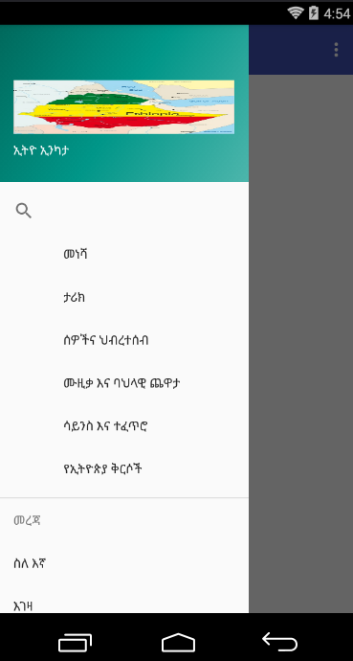

Figure 28: Amharic mobile user menu items

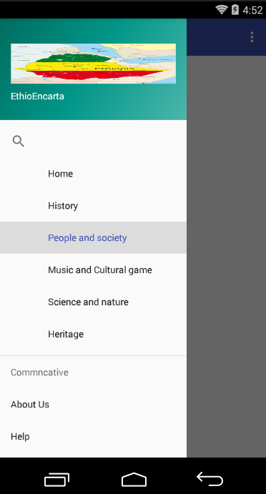

Figure 29: Amharic mobile user menu items

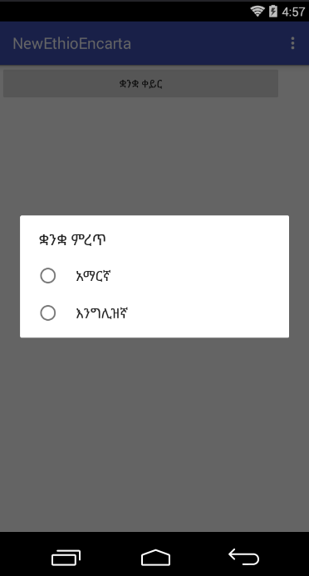

Figure 30 :Setting for Application

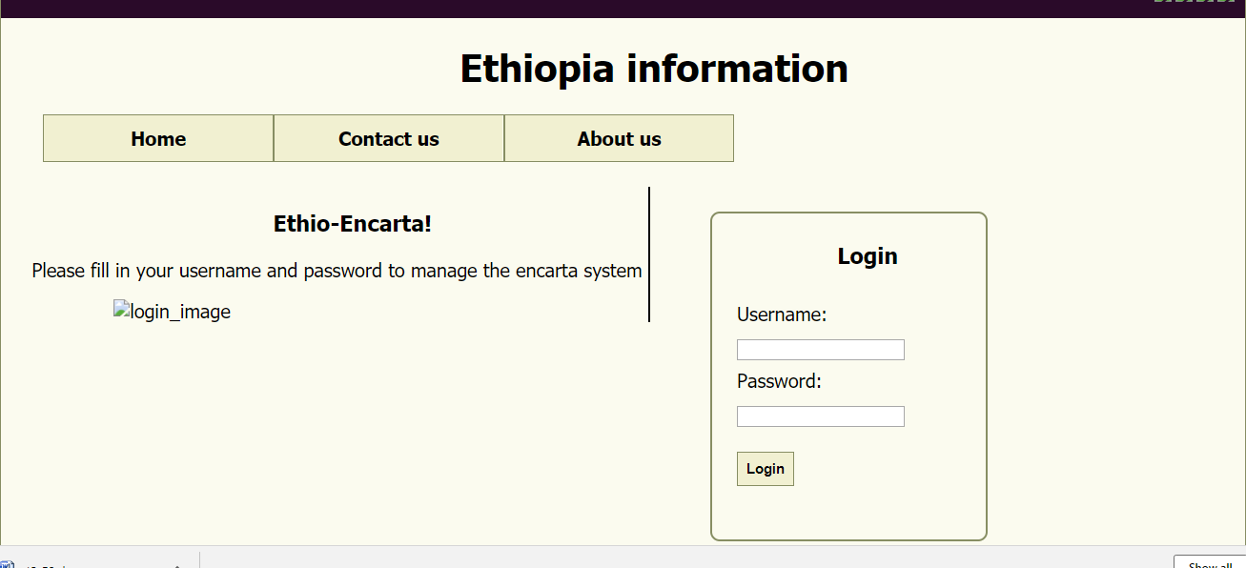

Figure 31: Login page

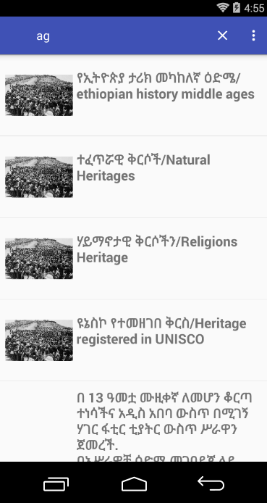

Figure 32: Search Information

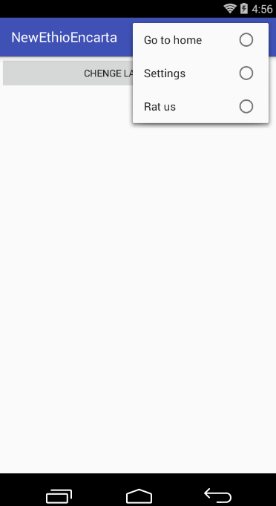

Figure 33: Meanu

Coding

Search sample code

**package** com.example.encarta.newethioencarta;**import** android.content.Intent;  
**import** android.support.v4.view.GravityCompat;  
**import** android.support.v4.widget.DrawerLayout;  
**import** android.support.v7.app.ActionBar;  
**import** android.support.v7.app.AppCompatActivity;  
**import** android.os.Bundle;  
**import** android.support.v7.widget.SearchView;  
**import** android.text.TextUtils;  
**import** android.view.Menu;  
**import** android.view.MenuItem;  
**import** android.widget.ListView;  
  
**import** com.example.encarta.newethioencarta.hertages.Heritage;  
**import** com.example.encarta.newethioencarta.history.Historys;  
**import** com.example.encarta.newethioencarta.humans.Humans;  
**import** com.example.encarta.newethioencarta.sance.Scince_and_Nature;  
  
**import** java.util.ArrayList;  
  
**public class** MainActivity **extends** AppCompatActivity {  
  
 ListView **listView**;  
 ListViewAdapter **adapter**;  
 String[] **title**;  
 String[] **description**;  
**int**[] **icon**;  
 ArrayList<Model>**arrayList** = **new** ArrayList<Model>();  
@Override  
**protected void** onCreate(Bundle savedInstanceState) {  
**super**.onCreate(savedInstanceState);  
 setContentView(R.layout.***activity_main***);  
  
 ActionBar actionBar = getSupportActionBar();  
 actionBar.setTitle(**"search Information"**);  
  
**title** = **new** String[]{**"lucy"**,  
**"lalibela"**,  
**"axsum"**,  
**"ቅድመ ታሪክ/Prehistory"**,  
**"የጥንት የኢትዮጵያ ታሪክ/antiquity ethiopia history"**,  
**"የኢትዮጵያ ታሪክ መካከለኛ ዕድሜ/ethiopian history middle ages"**,  
**"ዘመናዊ የኢትዮጵያ ታሪክ/modern history of Ethiopian"**,  
**"የኢትዮጵያን ቀልዶች/Ethiopia Jokes"**,  
**"የኢትዮጵያ የሙዚቃ ታሪክ/Ethiopian music history"**,  
**"የሙዚቃ መሳሪያ/musical_instrument"**, **"ስፖርት/sports"**,  
**"ተፈጥሯዊ ቅርሶች/Natural Heritages"**,  
**"ሃይማኖታዊ ቅርሶችን/Religions Heritage"**,  
**"ዩኔስኮ የተመዘገበ ቅርስ/Heritage registered in UNISCO"**,  
**"በ 13 ዓመቷ ሙዚቀኛ ለመሆን ቆርጣ ተነሳችና አዲስ አበባ ውስጥ በሚገኝ ሃገር ፋቲር ቲያትር ውስጥ ሥራዋን ጀመረች.\n"** +  
**"በአሥራዎቹ ዕድሜ መገባደጃ ላይ ከጀመረች በኋላ በዋና ከተማዋ ክለቦች እና ሆቴሎች ውስጥ እንደ ሬስቶን ባንድ ከመሆኑ በፊት እንደ ካቲን ባንድ, ሆቴል አፍሪካ ባንድ, ሸቤል ባንድ እና አይቤክስ ባንድ ባሉ ዘፈኖች ያከናውን ነበር.\n"** +  
**"አስቴር የተለያዩ ዘይቤዎች ተካተዋል.እንዲሁም ሌሎች እንደ ኢትዮጵያዊ ዘፋኞች ተፅእኖ አሳድሯል.\n"** +  
**"የሙዚቃ ሥራን መጀመር, አምስት ታት እና ሁለት የሙዚቃ ዜማዎችን ገንዘብ ለግስለት እና ለፖስታ ያደረገችውን የሙዚቃ አሠልጣኝ አሊ ታንጎን ተበረታታች. በ 1981 እ.ኤ.አ. አስቴር ኢትዮጵያን ግራ መጋባት የጣለችው የአጼ ኃይለስላሴ ሞት ከተገደለ በኋላ ወደ ዩናይትድ ስቴትስ ተዛውሮ ነበር. በካሊፎርኒያ የባህር ወሽመጥ አካባቢ በጊዜያዊነት ለመቋቋም በ 2 ዓመት ጊዜ ውስጥ ከፍተኛ ትምህርት ለመከታተል ዕቅድ በማውጣቷ በሀገሪቱ ካሉት ትላልቅ የኢትዮጵያውያን ማህበራት መካከል ዋነኛው ነው.እዚያም በኢትዮጵያውያን ማህበረሰብ ውስጥ በሆቴሎችና በክለቦች ውስጥ እየሰራች ትታወቃለች.\n"** +  
**"አስቴር በኢትዮጵያ ውስጥም ታዋቂ ሆኗል. እ.ኤ.አ. በ 1997 ዓ.ም ከ 50 ሺህ ለሚበልጡ ሰዎች በአዲስ አበባ ውስጥ አከናወነች. እ.ኤ.አ. በ 2003 አስቴር በኢትዮጵያ ለሚኖሩ የእርዳታ እና የትምህርት ተቋማት ገንዘብ ለማሰባሰብ ሁለት ተከታታይ ኮንሰርት ተከታታይ ሠርቷል.የመጀመሪያው የሙዚቃ ዝግጅት በአዲስ አበባ ስታዲየም ውስጥ በኢድ አል-ፊጥር ቀን 40,000 ተሰብሳቢዎች ተገኝተዋል. ሁለተኛው ትርዒት በሸራተን ሆቴል የአንድ ጋቢ እራት ነበር. [2] በቅርብ ጊዜ ግንቦት 9 ቀን 2009 Aster በ A ርት ህብረት በ A ንድነት ዩኒቲ በሚኒየም መድረክ ከሌሎች የ I ትዮጵያ የሥነ-ጥበብ አርቲስቶች ጋር በተካሄደው የ A ርት ህብረት በ 10,000 ተመልካቾች ፊት ነበር.\n"** +  
**"By the age of 13, Aster was determined to become a musician, and began her career at Hager Fikir Theatre in Addis Ababa.Starting in her late teens, she was performing in clubs and hotels in the capital with bands such as the Continental Band, Hotel D Afrique Band, Shebele Band and Ibex Band, before they became the internationally known as Roha Band.Aster is distinct style has been influenced by other Ethiopian singers, such as Bizunesh Bekele\n"** +  
**"Launching a solo career, she was encouraged by musical entrepreneur Ali Tango, who financed and released five cassettes and two singles of her music. By 1981, Aster had become disillusioned by Ethiopia is oppressive political climate following the death of Haile Selassie, and relocated to the United States. Temporarily settling in the Bay Area of California, with plans to pursue higher education within a period of two years, she settled in Washington, D.C., where one of the largest Ethiopian expat communities in the country existed. There, she became increasingly popular within the Ethiopian community, performing in restaurants and clubs\n"** +  
**"Aster also remains popular in Ethiopia. In 1997, she performed in Addis Ababa for a crowd of over 50,000 people. In 2003, Aster also performed a two-part\" \n"** +  
**"concert series to raise funds for relief and school initiatives in Ethiopia. The first concert was held in November on Eid Al-Fitr day at the Addis Ababa\" \n"** +  
**"Stadium, with an audience of 40,000 in attendance. The second performance was a gala-dinner at the Sheraton Hotel More recently, on May 9, 2009, Aster \n"** +  
**"\"performed in front of a crowd of 10,000 spectators during the Peace Through Unity, Unity Through Music concert held in the capital's Millennium Hall, \n"** +  
**"\"alongside other Ethiopian music artists\n"**,  
**"Emperor Tewodros (or Theodore) II was born Lij Kassa in Qwara, in 1818. His father was a small local chief, and his relative (possibly uncle) Dejazmach Kinfu was governor of the provinces of Dembiya, Qwara and Chelga between Lake Tana and the northwestern frontier. Kassa lost his inheritance upon the death of Kinfu while he was still a young boy. After receiving a traditional education in a local monastery, he went off to lead a band of bandits that roved the country in a Robin Hood-like existence. His exploits became widely known, and his band of followers grew steadily until he led a formidable army. He came to the notice of the ruling Regent, Ras Ali, and his mother Empress Menen Liben Amede (wife of the Emperor Yohannes III). In order to bind him to them, the Empress arranged for Kassa to marry Alis daughter. He turned his attention to conquering the remaining chief divisions of the country, Gojjam, Tigray and Shewa, which still remained unsubdued. His relations with his father-in-law and grandmother-in-law deteriorated however, and he soon took up arms against them and their vassals, and was successful.\n"** +  
**"On February 11, 1855, Kassa deposed the last of the Gondarine puppet Emperors, and was crowned negusa nagast of Ethiopia under the name of Tewodros II. He soon after advanced against Shewa with a large army. Chief of the notables opposing him was its king Haile Melekot, a descendant of Meridazmach Asfa Wossen. Dissensions broke out among the Shewans, and after a desperate and futile attack on Tewodros at Dabra Berhan, Haile Melekot died of illness, nominating with his last breath his eleven-year-old son as successor (November 1855) under the name Negus Sahle Maryam (the future emperor Menelek II). Darge, Haile Melekots brother, and Ato Bezabih, a Shewan noble, took charge of the young prince, but after a hard fight with Angeda, the Shewans were obliged to capitulate. Sahle Maryam was handed over to the Emperor Tewodoros and taken to Gondar. He was trained there in Tewodros's service, and then placed in comfortable detention at the fortress of Magdala. Tewodoros afterwards devoted himself to modernizing and centralizing the legal and administrative structure of his kingdom, against the resistance of his governors. Sahle Maryam of Shewa was married to Tewodros II's daughter Alitash.\n"** +  
**"In 1865, Sahle Maryam escaped from Magdala, abandoning his wife, and arrived in Shewa, and was there acclaimed as Negus. Tewodros forged an alliance between Britain and Ethiopia, but as explained in the next section, he committed suicide after a military defeat by the British. On the death of Tewodros, many Shewans, including Ras Darge, were released, and the young Negus of Shewa began to feel himself strong enough, after a few preliminary minor campaigns, to undertake offensive operations against the northern princes. However, these projects were of little avail, for Ras Kassai of Tigray had by this time (1872) risen to supreme power in the north. Proclaiming himself negusa nagast under the name of Yohannes IV (or John IV), he forced Sahle Maryam to acknowledge his overlordship. ንጉሠ ነገሥት ቴዎድሮስ (ወይም ቴዎዶር) II የተወለደው በ 1818 ኩዊራ ውስጥ ሊጃ ካሳ ነበር. አባቱ ትንሽ የአካባቢው አለቃ ነበር, እና ዘመድ (ምናልባትም አጎቱ) ደጃዝማች ኪኖ የአዲምቢያ, የቁዋራ እና የኬላ ግዛቶች ገዥ ነበር. ሰሜን ምዕራብ ድንበር. ካሣ በወጣ ትንሹ ልጅ እያለ ኪንፉ በሞተበት ጊዜ የነበረውን ውርሻ አጣ. በአካባቢው ገዳም ውስጥ ባህላዊ ትምህርት ከተከታተለ በኋላ በሮቢን ሁድ-መሰል ሕንፃ ውስጥ ሀገርን ለመንሸራሸር የሽኝት ቡድን ለመምራት ቀጠለ. ክርክሮቹ በሰፊው የታወቁ ሲሆን ተከታይ ቡድኖቹ አንድ ትልቅ ሠራዊት እስከተሳለፉበት ጊዜ ድረስ በቋሚነት እያደገ ሄደ. ለገዢው ንጉስ ሬያስ ዒሊስ እና ለወንድም እቴጌ መነን ሊቤን አማዴ (የአ Em ዮሐንስ ዮሀስ ሚስቶች ሚስት) ማስጠንቀቂያ ደረሰ. ንግስቲቱ እሳቸውም እንዲሰሩ ካሣ, የአሊስ ሴት ልጅ እንዲያገባ ለማድረግ ቀጠለች. ቀሪዎቹን የአገሪቱን ዋና ጎሳዎች, ጎጃም, የትግራይ እና ሸዋ ድል ለመንሳት ወደ ኋላ ዞረ. ይሁን እንጂ ከአማቱና ከአያቱ ጋር የነበረው ግንኙነት እያሽቆለቆለ ሄደ; ብዙም ሳይቆይ ግን በእነሱና በቫሳልያው በእነሱ ላይ መሣሪያ ያነሳ ሲሆን ስኬታማ ነበር.\n"** +  
**"የካቲት 11, 1855 ካሳ የጅንዳኔን አሻንጉሊት ንጉሶች አቁሞ አራተኛውን የኢትዮጵያ አጼ ቴዎድሮስ (አጼ ቴዎድሮስ) አስቆጥረውታል. እሱ ብዙም ሳይቆይ በሸሸን ታላቅ ሰራዊት ጋር ለመግጠም ተገደደ. የተቃውሞው ዋና አለቃ የነበረው የንጉሥ ሀለለም ሜለካት, ከሜሪዝዛክ አሲፋ አሶስ ተወላጅ ነበር. በሼዋኖች መካከል ውህደቶች ተከፈቱ, እና ኃይለስ መሌክ በቴውዎሮስ ላይ በደረሰው ድብደባ እና ድካም ላይ ከወደመ በኋላ በ 11 አመት እድሜው ህይወቱን ሞተ. (ኖቬምበር 1855) በአጎስ ሳህል ማርያም (የወደፊቱ ንጉሠ ነገሥት ሜንዴክ II). ዳጌ, ሃይሌ ሜለክስስ ወንዴም, እና የቦሸን ወ / ሮ ባሴቢህ የሽዋን መሪ የነበሩትን ወጣት አለቃን ተቆጣጠሩ. ነገር ግን ከኤውዳአዎች ጋር ጠንካራ ግጭት ከተፈጠረ በኋላ ሸዋኖች የመምታት ግዴታ ነበረባቸው. ሳህል ማርያም ወደ ንጉሱ ቴዎድሮስ ተወስዶ ወደ ጎንደር ተወሰደ. በቴውዞሮስ አገልግሎት ተሠለጠነ እና ከዚያም በመጋዴል ምሽት በእስር ቤት ውስጥ ታስሮ ቆይቷል. ከዚህ በኋላ ቴዎድሮስ መንግስታዊውን ህጋዊ እና አስተዳደራዊ አወቃቀሩ, የገዥዎቿን ተቃውሞ ለመግታትና ለማብሰር ቆርጦ ነበር. ሳህል ማጃማም ሸዋ የአጼ ቴዎድሮስ 2 ኛ ልጅ የአቲትሽ ልጅ አገባች.\n"** +  
**"በ 1865 ሳህል ሜሪም ሚስቱን በመተው ከስዊድን ሸሽቶ ወደ ሸዋ ደረሰች. ቴዎድሮስ በብሪቲሽ እና በኢትዮጵያ መካከል ጥምረት ፈጠረ. በሚቀጥለው ክፍል እንደተገለፀው የእንግሊዛዊያን ወታደራዊ ድል ከተቀዳጀ በኋላ እራሳቸውን ለማጥፋት ጀመሩ. ቴውድሮስ ሲሞት የራስ ዳደንን ጨምሮ ብዙ ሳዋንሶች ከእስር ተለቀዋል. ሸዋ የተባለው ወጣት ጎሳ ደግሞ ከጥቂት የመጀመሪያ ዘመቻዎች በኋላ በሰሜናዊ ልዑካን ላይ አስፈሪ ተግባር እንዲፈጽም ተደረገ. ይሁን እንጂ እነዚህ ፕሮጀክቶች ብዙም አልነበሩም, ምክንያቱም በዚህ ወቅት (1872) ራጋ ካሸይ በሰሜን በኩል ወደ ከፍተኛ ሥልጣን ተጨመረ. ሰላም ማሰማት\n"** +  
**" \n"** +  
**"\n"** +  
**"\n"**};  
  
**icon** = **new int**[]{R.drawable.***lucy***,  
 R.drawable.***lalibela***,  
 R.drawable.***axsum***,  
 R.drawable.***pre***,  
 R.drawable.***war***,  
 R.drawable.***war***,  
 R.drawable.***war***,  
 R.drawable.***lucy***,  
 R.drawable.***lalibela***,  
 R.drawable.***axsum***,  
 R.drawable.***pre***,  
 R.drawable.***war***,  
 R.drawable.***war***,  
 R.drawable.***war***,  
 R.drawable.***aster_aweke***,  
 R.drawable.***aster_aweke***};  
  
**listView** = findViewById(R.id.***listView***);  
  
**for** (**int** i =0; i<**title**.**length**; i++){  
 Model model = **new** Model(**title**[i], **description**[i], **icon**[i]);  
**arrayList**.add(model);  
 }  
  
**adapter** = **new** ListViewAdapter(**this**, **arrayList**);  
**listView**.setAdapter(**adapter**);  
  
 }  
  
 @Override  
**public boolean** onCreateOptionsMenu(Menu menu) {  
 getMenuInflater().inflate(R.menu.***menu***, menu);  
  
 MenuItem myActionMenuItem = menu.findItem(R.id.***action_search***);  
 SearchView searchView = (SearchView)myActionMenuItem.getActionView();  
 searchView.setOnQueryTextListener(**new** SearchView.OnQueryTextListener() {  
 @Override  
**public boolean** onQueryTextSubmit(String s) {  
**return false**;  
 }  
  
 @Override  
**public boolean** onQueryTextChange(String s) {  
**if** (TextUtils.*isEmpty*(s)){  
**adapter**.filter(**""**);  
**listView**.clearTextFilter();  
 }  
**else** {  
**adapter**.filter(s);  
 }  
**return true**;  
 }  
 });  
**return true**;  
 }  
  
 @Override  
**public boolean** onOptionsItemSelected(MenuItem item) {  
**int** id = item.getItemId();  
  
**if** (id==R.id.***action_settings***){  
**return true**;  
 }  
**return super**.onOptionsItemSelected(item);  
 }  
 @SuppressWarnings(**"StatementWithEmptyBody"**)  
  
**public boolean** onNavigationItemSelected(MenuItem item) {  
**int** id = item.getItemId();  
  
**if** (id == R.id.***Search***) {  
 Intent Search=**new** Intent(MainActivity.**this**, com.example.encarta.newethioencarta.MainActivity.**class**);  
 startActivities(**new** Intent[]{Search});  
  
**if** (id == R.id.***home***) {  
 Intent Home = **new** Intent( MainActivity.**this**, com.example.encarta.newethioencarta.Home.**class** );  
 startActivities( **new** Intent[]{Home} );  
 }  
 } **else if** (id == R.id.***history***) {  
 Intent History=**new** Intent(MainActivity.**this**,Historys.**class**);  
 startActivities(**new** Intent[]{History});  
  
 } **else if** (id == R.id.***human***) {  
  
 Intent Human=**new** Intent(MainActivity.**this**,Humans.**class**);  
 startActivities(**new** Intent[]{Human});  
  
 } **else if** (id == R.id.***music***) {  
  
 Intent Human=**new** Intent(MainActivity.**this**,Musicandc.**class**);  
 startActivities(**new** Intent[]{Human});  
  
 } **else if** (id == R.id.***netur***) {  
  
 Intent Human=**new** Intent(MainActivity.**this**,Scince_and_Nature.**class**);  
 startActivities(**new** Intent[]{Human});  
  
 } **else if** (id == R.id.***hritage***) {  
 Intent Human=**new** Intent(MainActivity.**this**,Heritage.**class**);  
 startActivities(**new** Intent[]{Human});  
  
 }  
  
 DrawerLayout drawer = (DrawerLayout) findViewById(R.id.***drawer_layout***);  
 drawer.closeDrawer( GravityCompat.***START***);  
**return true**;  
 }  
}  
**package** com.example.encarta.newethioencarta;  
**import** android.content.Context;  
**import** android.content.Intent;  
**import** android.view.LayoutInflater;  
**import** android.view.View;  
**import** android.view.ViewGroup;  
**import** android.widget.BaseAdapter;  
**import** android.widget.ImageView;  
**import** android.widget.TextView;  
  
**import** com.example.encarta.newethioencarta.culturalgemsandmusic.Ethiopianjoks;  
**import** com.example.encarta.newethioencarta.culturalgemsandmusic.Musicalhistory;  
**import** com.example.encarta.newethioencarta.culturalgemsandmusic.Musicalinstrument;  
**import** com.example.encarta.newethioencarta.culturalgemsandmusic.Sport;  
**import** com.example.encarta.newethioencarta.hertages.Ethiuniscohirt;  
**import** com.example.encarta.newethioencarta.hertages.Naturalhrtagedescrpt;  
**import** com.example.encarta.newethioencarta.hertages.Religoushrti;  
**import** com.example.encarta.newethioencarta.history.Ethiomiddle;  
**import** com.example.encarta.newethioencarta.history.Ethiopiaanisint;  
**import** com.example.encarta.newethioencarta.history.Gondarperiod;  
**import** com.example.encarta.newethioencarta.history.Modernethiopia;  
**import** com.example.encarta.newethioencarta.history.Perehisory;  
**import** com.example.encarta.newethioencarta.humans.Govtandlaws;  
**import** com.example.encarta.newethioencarta.humans.cultures.Holidays;  
**import** com.example.encarta.newethioencarta.humans.famous.Hailegrma;  
  
**import** java.util.ArrayList;  
**import** java.util.List;  
**import** java.util.Locale;  
  
**public class** ListViewAdapter **extends** BaseAdapter{  
  
*//variables*Context **mContext**;  
 LayoutInflater **inflater**;  
 List<Model>**modellist**;  
 ArrayList<Model>**arrayList**;  
  
*//constructor***public** ListViewAdapter(Context context, List<Model> modellist) {  
**mContext** = context;  
**this**.**modellist** = modellist;  
**inflater** = LayoutInflater.*from*(**mContext**);  
**this**.**arrayList** = **new** ArrayList<Model>();  
**this**.**arrayList**.addAll(modellist);  
 }  
  
**public class** ViewHolder{  
 TextView **mTitleTv**, **mDescTv**;  
 ImageView **mIconIv**;  
 }  
  
 @Override  
**public int** getCount() {  
**return modellist**.size();  
 }  
  
 @Override  
**public** Object getItem(**int** i) {  
**return modellist**.get(i);  
 }  
  
 @Override  
**public long** getItemId(**int** i) {  
**return** i;  
 }  
  
 @Override  
**public** View getView(**final int** postition, View view, ViewGroup parent) {  
 ViewHolder holder;  
**if** (view==**null**){  
 holder = **new** ViewHolder();  
 view = **inflater**.inflate(R.layout.***row***, **null**);  
  
*//locate the views in row.xml*holder.**mTitleTv** = view.findViewById(R.id.***mainTitle***);  
 holder.**mDescTv** = view.findViewById(R.id.***mainDesc***);  
 holder.**mIconIv** = view.findViewById(R.id.***mainIcon***);  
 view.setTag(holder);  
 }  
**else** {  
 holder = (ViewHolder)view.getTag();  
 }holder.**mTitleTv**.setText(**modellist**.get(postition).getTitle());  
 holder.**mDescTv**.setText(**modellist**.get(postition).getDesc());holder.**mIconIv**.setImageResource(**modellist**.get(postition).getIcon());view.setOnClickListener(**new** View.OnClickListener() {  
 @Override  
**public void** onClick(View view) {**if** (**modellist**.get(postition).getTitle().equals(**"lucy"**)){  
Intent intent = **new** Intent(**mContext**, Ethiuniscohirt.**class**);  
  
**mContext**.startActivity(intent);  
 }  
**if** (**modellist**.get(postition).getTitle().equals(**"lalibela"**)){Intent intent = **new** Intent(**mContext**, Govtandlaws.**class**);  
  
**mContext**.startActivity(intent);  
 }  
**if** (**modellist**.get(postition).getTitle().equals(**"axsum"**)){  
Intent intent = **new** Intent(**mContext**, Gondarperiod.**class**);  
  
**mContext**.startActivity(intent);  
 }  
**if** (**modellist**.get(postition).getTitle().equals(**"ቅድመ ታሪክ/Prehistory"**)){  
Intent intent = **new** Intent(**mContext**, Perehisory.**class**);  
  
**mContext**.startActivity(intent);  
 }  
**if** (**modellist**.get(postition).getTitle().equals(**"የጥንት የኢትዮጵያ ታሪክ/antiquity ethiopia histor"**)){  
Intent intent = **new** Intent(**mContext**, Ethiopiaanisint.**class**);  
  
**mContext**.startActivity(intent);  
 }  
**if** (**modellist**.get(postition).getTitle().equals(**"የኢትዮጵያ ታሪክ መካከለኛ ዕድሜ/ethiopian history middle ages"**)){  
Intent intent = **new** Intent(**mContext**, Ethiomiddle.**class**);  
  
**mContext**.startActivity(intent);  
 }  
**if** (**modellist**.get(postition).getTitle().equals(**"ዘመናዊ የኢትዮጵያ ታሪክ/modern history of Ethiopian"**)){  
Intent intent = **new** Intent(**mContext**, Modernethiopia.**class**);  
  
**mContext**.startActivity(intent);  
 }  
**if** (**modellist**.get(postition).getTitle().equals(**"የኢትዮጵያን ቀልዶች/Ethiopia Jokes"**)){  
Intent intent = **new** Intent(**mContext**, Ethiopianjoks.**class**);  
  
**mContext**.startActivity(intent);  
 }  
**if** (**modellist**.get(postition).getTitle().equals(**"የኢትዮጵያ የሙዚቃ ታሪክ/Ethiopian music history"**)){  
Intent intent = **new** Intent(**mContext**, Musicalhistory.**class**);  
  
**mContext**.startActivity(intent);  
 }  
**if** (**modellist**.get(postition).getTitle().equals(**"የሙዚቃ መሳሪያ/musical_instrument"**)){  
Intent intent = **new** Intent(**mContext**, Musicalinstrument.**class**);  
 intent.putExtra(**"actionBarTitle"**, **"Display"**);  
  
**mContext**.startActivity(intent);  
 }  
**if** (**modellist**.get(postition).getTitle().equals(**"ስፖርት/sports"**)){  
Intent intent = **new** Intent(**mContext**, Sport.**class**);  
  
**mContext**.startActivity(intent);  
 }  
**if** (**modellist**.get(postition).getTitle().equals(**"ተፈጥሯዊ ቅርሶች/Natural Heritagesr"**)){Intent intent = **new** Intent(**mContext**, Naturalhrtagedescrpt.**class**);  
  
**mContext**.startActivity(intent);  
 }  
**if** (**modellist**.get(postition).getTitle().equals(**"ሃይማኖታዊ ቅርሶችን/Religions Heritage"**)){Intent intent = **new** Intent(**mContext**, Religoushrti.**class**);  
  
**mContext**.startActivity(intent);  
 }  
**if** (**modellist**.get(postition).getTitle().equals(**"ዩኔስኮ የተመዘገበ ቅርስ/Heritage registered in UNISCO"**)){  
Intent intent = **new** Intent(**mContext**, Ethiuniscohirt.**class**);  
  
**mContext**.startActivity(intent);  
 }  
**if** (**modellist**.get(postition).getTitle().equals(**"በ 13 ዓመቷ ሙዚቀኛ ለመሆን ቆርጣ ተነሳችና አዲስ አበባ ውስጥ በሚገኝ ሃገር ፋቲር ቲያትር ውስጥ ሥራዋን ጀመረች.\n"** +  
**"\n"** +  
**"በአሥራዎቹ ዕድሜ መገባደጃ ላይ ከጀመረች በኋላ በዋና ከተማዋ ክለቦች እና ሆቴሎች ውስጥ እንደ ሬስቶን ባንድ ከመሆኑ በፊት እንደ ካቲን ባንድ, ሆቴል አፍሪካ ባንድ, ሸቤል ባንድ እና አይቤክስ ባንድ ባሉ ዘፈኖች ያከናውን ነበር.\n"** +  
**"\n"** +  
**"አስቴር የተለያዩ ዘይቤዎች ተካተዋል.እንዲሁም ሌሎች እንደ ኢትዮጵያዊ ዘፋኞች ተፅእኖ አሳድሯል.\n"** +  
**"\n"** +  
**"የሙዚቃ ሥራን መጀመር, አምስት ታት እና ሁለት የሙዚቃ ዜማዎችን ገንዘብ ለግስለት እና ለፖስታ ያደረገችውን \u200B\u200Bየሙዚቃ አሠልጣኝ አሊ ታንጎን ተበረታታች. በ 1981 እ.ኤ.አ. አስቴር ኢትዮጵያን ግራ መጋባት የጣለችው የአጼ ኃይለስላሴ ሞት ከተገደለ በኋላ ወደ ዩናይትድ ስቴትስ ተዛውሮ ነበር. በካሊፎርኒያ የባህር ወሽመጥ አካባቢ በጊዜያዊነት ለመቋቋም በ 2 ዓመት ጊዜ ውስጥ ከፍተኛ ትምህርት ለመከታተል ዕቅድ በማውጣቷ በሀገሪቱ ካሉት ትላልቅ የኢትዮጵያውያን ማህበራት መካከል ዋነኛው ነው.እዚያም በኢትዮጵያውያን ማህበረሰብ ውስጥ በሆቴሎችና በክለቦች ውስጥ እየሰራች ትታወቃለች.\n"** +  
**"\n"** +  
**"አስቴር በኢትዮጵያ ውስጥም ታዋቂ ሆኗል. እ.ኤ.አ. በ 1997 ዓ.ም ከ 50 ሺህ ለሚበልጡ ሰዎች በአዲስ አበባ ውስጥ አከናወነች. እ.ኤ.አ. በ 2003 አስቴር በኢትዮጵያ ለሚኖሩ የእርዳታ እና የትምህርት ተቋማት ገንዘብ ለማሰባሰብ ሁለት ተከታታይ ኮንሰርት ተከታታይ ሠርቷል.የመጀመሪያው የሙዚቃ ዝግጅት በአዲስ አበባ ስታዲየም ውስጥ በኢድ አል-ፊጥር ቀን 40,000 ተሰብሳቢዎች ተገኝተዋል.ሁለተኛው ትርዒት \u200B\u200Bበሸራተን ሆቴል የአንድ ጋቢ እራት ነበር. [2] በቅርብ ጊዜ ግንቦት 9 ቀን 2009 Aster በ A ርት ህብረት በ A ንድነት ዩኒቲ በሚኒየም መድረክ ከሌሎች የ I ትዮጵያ የሥነ-ጥበብ አርቲስቶች ጋር በተካሄደው የ A ርት ህብረት በ 10,000 ተመልካቾች ፊት ነበር.\n"** +  
**" By the age of 13, Aster was determined to become a musician, and began her career at Hager Fikir Theatre in Addis Ababa.\n"** +  
**"\n"** +  
**"Starting in her late teens, she was performing in clubs and hotels in the capital with bands such as the Continental Band, Hotel D Afrique Band, Shebele Band and Ibex Band, before they became the internationally known as Roha Band.\n"** +  
**"\n"** +  
**"Aster is distinct style has been influenced by other Ethiopian singers, such as Bizunesh Bekele.\n"** +  
**"\n"** +  
**"Launching a solo career, she was encouraged by musical entrepreneur Ali Tango, who financed and released five cassettes and two singles of her music. By 1981, Aster had become disillusioned by Ethiopia is oppressive political climate following the death of Haile Selassie, and relocated to the United States. Temporarily settling in the Bay Area of California, with plans to pursue higher education within a period of two years, she settled in Washington, D.C., where one of the largest Ethiopian expat communities in the country existed. There, she became increasingly popular within the Ethiopian community, performing in restaurants and clubs.\n"** +  
**"\n"** +  
**"Aster also remains popular in Ethiopia. In 1997, she performed in Addis Ababa for a crowd of over 50,000 people. In 2003, Aster also performed a two-part"** +  
**" concert series to raise funds for relief and school initiatives in Ethiopia. The first concert was held in November on Eid Al-Fitr day at the Addis Ababa"** +  
**" Stadium, with an audience of 40,000 in attendance. The second performance was a gala-dinner at the Sheraton Hotel.[2] More recently, on May 9, 2009, Aster "** +  
**"performed in front of a crowd of 10,000 spectators during the Peace Through Unity, Unity Through Music concert held in the capital's Millennium Hall, "** +  
**"alongside other Ethiopian music artists\n"**)){Intent intent = **new** Intent(**mContext**, Ethiuniscohirt.**class**);  
  
**mContext**.startActivity(intent);  
 }  
 }  
 });  
**return** view;  
 }  
  
*//filter***public void** filter(String charText){  
 charText = charText.toLowerCase(Locale.*getDefault*());  
**modellist**.clear();  
**if** (charText.length()==0){  
**modellist**.addAll(**arrayList**);  
 }  
**else** {  
**for** (Model model : **arrayList**){  
**if** (model.getTitle().toLowerCase(Locale.*getDefault*())  
 .contains(charText)){  
**modellist**.add(model);  
 }  
 }  
 }  
 notifyDataSetChanged();  
 }  
  
}

**package**com.example.encarta.newethioencarta;**public class** Model {  
 String **title**;  
 String **desc**;  
**int icon**;  
  
*//constructor***public** Model(String title, String desc, **int** icon) {  
**this**.**title** = title;  
**this**.**icon** = icon;  
 }  
  
*//getters***public** String getTitle() {  
**return this**.**title**;  
 }  
  
**public** String getDesc() {  
**return this**.**desc**;  
 }  
  
**public int** getIcon() {  
**return this**.**icon**;  
 }  
}

Search activity

*<?***xml version="1.0" encoding="utf-8"***?>*<**LinearLayout xmlns:android="http://schemas.android.com/apk/res/android"  
 xmlns:app="http://schemas.android.com/apk/res-auto"  
 xmlns:tools="http://schemas.android.com/tools"  
 android:layout_width="match_parent"  
 android:layout_height="match_parent"  
 tools:context=".MainActivity"**>  
  
<**ListView  
 android:id="@+id/listView"  
 android:layout_width="match_parent"  
 android:layout_height="match_parent"**>  
</**ListView**>  
  
</**LinearLayout**>

*<?***xml version="1.0" encoding="utf-8"***?>*<**LinearLayout  
 xmlns:android="http://schemas.android.com/apk/res/android"  
 android:layout_width="match_parent"  
 android:layout_height="wrap_content"  
 android:orientation="horizontal"  
 android:gravity="center"  
 android:padding="10dp"**>  
  
<**ImageView  
 android:id="@+id/mainIcon"  
 android:src="@drawable/ic_launcher_background"  
 android:layout_width="100dp"  
 android:layout_height="100dp"** />  
<**LinearLayout  
 android:layout_width="match_parent"  
 android:layout_height="wrap_content"  
 android:orientation="vertical"  
 android:gravity="center"  
 android:layout_marginLeft="5dp"  
 android:layout_marginStart="5dp"**>  
<**TextView  
 android:id="@+id/mainTitle"  
 android:text="Title"  
 android:textStyle="bold"  
 android:textSize="20sp"  
 android:layout_width="match_parent"  
 android:layout_height="wrap_content"** />  
  
</**LinearLayout**>  
  
</**LinearLayout**>

## Start-up strategy

The start-up strategy will be:

For server side:

* Buying a domain name from a company with its corresponding IP address for the server.
* Hosting the database, the server
* Finally, available internet connection for the computer

For mobile application:

* First download the application from source
* Then install the application on mobile and use simply

# CHAPTERSEVEN: CONCLUSION ANDRECOMMENDATION

## Conclusions

We development this project with two phases; the first phase deals with the analysis phase of the development life cycle, and the next phase addresses design, implementation and testing issues. As the end of the first phase, we need to review what we have covered in accordance with what we have planned at the beginning. We planned to develop mobile based Ethio-Encarta. We began our work by identifying the problems for the registrar and the overall techniques to be used in the development process. This involved defining the system development methodology, identifying resource and cost requirements and setting the deliverables and schedule for the project. The business area analysis helps the team to truly understand the major functional areas and processes of the system. Through this we evaluated the existing system weakness and strength. After that we performed requirements elicitation to discover user and system requirements. This phase consider of drawing out the functional as well as non-functional requirements. Then we have undertaken a major phase in system development process. Object oriented analysis here we tried to model the new system we proposed using UML diagrams, use case, sequence. Activity and class diagram. Also we designed the new system user interface prototypes. Therefore we believe that what has been planned for the first phase of the project is accomplished. We set to develop a working system prototype that would solve the problems in the beginning of our project. The problems, which existed in the earlier system, have been removed to a large extent. And it is expected that this project will go a long way in satisfying user’s requirements.

## Recommendation

The system we have developed is mobile application system. Everyone who can use mobile can and use this application. We recommended that the system should be entitled to responsible person. User must have a basic knowledge of using mobile application. Also we recommend this application for Ethiopian Truism Head Office. This application is depending on Amharic and English language but the online information is only English language because the android studio framework not support Amharic language thenimplements the online information in Amharic and to address more people someone should develop by many local languages like Amharic, Oromifa, Tigirigna, and etc.… And also create this application into many platforms like (iPhone/iPad, cellular java phones, windows phones…). If is there anyone who want to improve our system, we recommend them to add some of the following features listed below.

* Multi region supporters: our system only deployed on Amharic and English but the Amharic information is offline there is no online information for Amharic users then we recommend that the next developer will consider all regions of Ethiopia language and make them online.

Appendix

**Unified modeling language (UML**): is standardizing modeling language enabling developers to specify, visualize, construct and document artifacts of a software system.

**User interface:** the means by which the user and a computer system interacts, in particular the use of input devices and software's.

**Password:** is a secrete word or phrase that must be used to gain admission to something. 79

**Use case diagram**: are a set of use cases, actors and their relationship. They represent the use case view of the system. A use case represents a particular functionality of the system.

**Sequence diagrams:** sequence diagram model the flow of logic within the system in a visual manner, enabling users both to document and validate logic, and are commonly used for both analysis and design purposes.

**Activity diagram**: activity diagram describes the flow of control in a system. So it consists of activities and links. The flow can be sequential, concurrent or branched

**Class diagram**: represents the object orientation of a system. So it is generally used for development purpose. This is the most widely used diagram at the time of the system.

Questionnaires

1. How much Mobile-based system is important?
2. Did you have mobile? And how you are need information about Ethiopia?
3. Did you need application that displays information about Ethiopia? Yes No
4. If you select yes in what language is you need?

Amharic

English

Other

1. Did you really select the language you need?

## References

# Bibliography

1. James Rumbaugh, M. B. (1999). *.Object-Oriented Modeling and Design.* Prentice-Hal.
2. Booch, G. R. (1997). *The Unified Modeling Language User Guide.* Addison-Wesley.
3. James Rumbaugh, I. J. (1999). The Unified Modeling Language Reference Manual. Addison-Wesley.
4. Schach, S. R. (1999). *Classical and Object-Oriented Software Engineering with UML and Java* ( 4th Edition ed.). WCB/McGraw-Hill.
5. SparxSystems*.*(2002).Retrieved from UMLTutorial”http://www.sparxsystems.com/resources/uml2_tutori/.
6. wikipedia*.* (n.d.). Retrieved from https://en.wikipedia.org/wiki/Ethiopia.